Error Handling

1. Try 2. Catch 3. Finally 4. Throw

<!-- The try statement defines a code block to run (to try).

The catch statement defines a code block to handle any error.

The finally statement defines a code block to run regardless of the result.

The throw statement defines a custom error. -->

<html>

    <body>

    <h1>Error Handling</h1>

    <h3>Enter a number between 5 to 10 </h3>

    <input id="i" type="text">

    <button type="button" onclick="on()">CLICK</button>

    <p id="p"></p>

    <script>

        function on()

        {

            var x = document.getElementById("i").value;

            var m = document.getElementById("p");

            try

            {

                if(x=="") throw "EMPTY"; // customize Exception throw

                if(isNaN(x)) throw "IS NOT A NUMBER";

                if(x<5) throw "TOO LOW";

                if(x>10) throw "TOO HIGH"

            }

            catch(e)

            {

                m.innerHTML = "ERROR:" + e;

            }

        }

    </script>

    </body>

    </html>

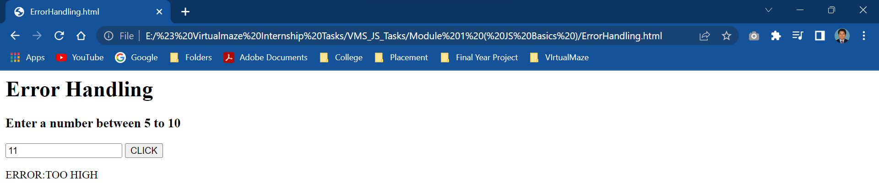

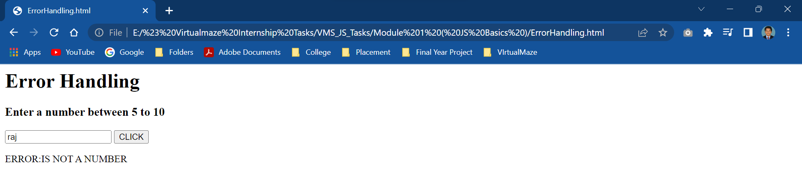

 <html>

    <body>

    <h1>Error Handling</h1>

    <p id="p"></p>

    <script>

        var a = Number(prompt("Enter a First Number"));

        document.write("A : ",a);

        var b = Number(prompt("Enter a Second Number"));

        document.write("<br><br>B : ",b);

        try{

            if(b==0)

            {

                throw{

                    error:"B is Zero"

                }

            }

            else

            {

                console.log(a/b);

            }

        }

        catch(e)

        {

            console.log(e.error);

        }

        finally

        {

            console.log("Finally Block is Always Executed");

        }

    </script>

    </body>

    </html>

